**Progressive Education Society’s**

**Modern College of Engineering, Shivajinagar, Pune-05.**

**Department of Electronics and Telecommunication**

**T. E. Mini Project Log Book**

**Academic Year: 2021-22**

**Project ID:- A8**

**Name of Student: - 1. Omkar Ankush Bhilare**

**2. Rishikesh Ghanshyam Datey**

**3. Neha Sandeepan Ghogre**

**Name of the Guide:-** Mr. Ramgopal Sahu

**Project Title: -** Dry/wet Garbage Segragation and Monitoring

**Progressive Education Society’s**

**Modern College of Engineering, Shivajinagar, Pune-05.**

**Department of Electronics and Telecommunication**

## QUALITY POLICY OF THE INSTITUTE

## We, PES Modern College of Engineering are committed to develop and foster cultured and promising professionals by imparting quality education in the field of Engineering and Management.

## VISION OF THE INSTITUTE

## To create a collaborative academic environment to foster professional excellence and ethical values

## MISSION OF THE INSTITUTE

1. **To develop outstanding engineers & professionals with high ethical standards capable of creating and managing global enterprises.**
2. **To foster innovation and research by providing a stimulating learning environment.**
3. **To ensure equitable development of students of all ability levels and backgrounds.**
4. **To be responsive to changes in technology, socio-economic levels and environmental conditions.**
5. **To foster and maintain mutually beneficial partnerships with alumni and industry.**

**Progressive Education Society’s**

**Modern College of Engineering, Shivajinagar, Pune-05.**

**Department of Electronics and Telecommunication**

**DEPARTMENTAL QUALITY POLICY**

**We at Department of Electronics and Telecommunication Engineering are committed to provide a comprehensive learning environment for all round development of our students.**

**DEPARTMENTAL MISSION**

1. **To impart quality Education in the field of Electronics, Communication and Signal processing, by providing a comprehensive learning experience.**
2. **To provide avenues to encourage students to continue education in diverse fields.**
3. **To develop competent Engineers, well-versed in multi-disciplinary fields.**
4. **To inculcate ethical and professional values in our students to endow society with responsible citizens.**

**DEPARTMENTAL VISION**

**To impart holistic Education in Electronics and Telecommunication Engineering to create engineers equipped to meet the challenges of a dynamic, global environment.**

**Progressive Education Society’s**

**Modern College of Engineering, Shivajinagar, Pune-05.**

**Department of Electronics and Telecommunication**

**PROGRAM OUTCOMES (POs)**

**Engineering Graduates will be able to:**

1. **Engineering knowledge**: Apply the knowledge of mathematics, science, engineering fundamentals, and an engineering specialization to the solution of complex engineering problems.
2. **Problem analysis**: Identify, formulate, review research literature, and analyze complex engineering problems reaching substantiated conclusions using first principles of mathematics, natural sciences, and engineering sciences.
3. **Design/development of solutions**: Design solutions for complex engineering problems and design system components or processes that meet the specified needs with appropriate consideration for the public health and safety, and the cultural, societal, and environmental considerations.
4. **Conduct investigations of complex problems**: Use research-based knowledge and research methods including design of experiments, analysis and interpretation of data, and synthesis of the information to provide valid conclusions.
5. **Modern tool usage**: Create, select, and apply appropriate techniques, resources, and modern engineering and IT tools including prediction and modeling to complex engineering activities with an understanding of the limitations.
6. **The engineer and society**: Apply reasoning informed by the contextual knowledge to assess societal, health, safety, legal and cultural issues and the consequent responsibilities relevant to the professional engineering practice.
7. **Environment and sustainability**: Understand the impact of the professional engineering solutions in societal and environmental contexts, and demonstrate the knowledge of, and need for sustainable development.
8. **Ethics**: Apply ethical principles and commit to professional ethics and responsibilities and norms of the engineering practice.
9. **Individual and team work**: Function effectively as an individual, and as a member or leader in diverse teams, and in multidisciplinary settings.
10. **Communication**: Communicate effectively on complex engineering activities with the engineering community and with society at large, such as, being able to comprehend and write effective reports and design documentation, make effective presentations, and give and receive clear instructions.
11. **Project management and finance**: Demonstrate knowledge and understanding of the engineering and management principles and apply these to one’s own work, as a member and leader in a team, to manage projects and in multidisciplinary environments.
12. **Life-long learning**: Recognize the need for, and have the preparation and ability to engage in independent and life-long learning in the broadest context of technological change.

**Progressive Education Society’s**

**Modern College of Engineering, Shivajinagar, Pune-05.**

**Department of Electronics and Telecommunication**

**PROGRAM EDUCATIONAL OBJECTIVES**

**The Electronics and Telecommunication Engineering Department of P.E.S’s MCOE will develop graduates who,**

1. **having diverse skills, will be able to pursue careers as Entrepreneurs, Engineers or Managers in Private or Government Sectors.**
2. **can continue their Education in the same field or diversify to Multi-disciplinary fields to emerge as Managers, Researchers or Teachers.**
3. **will continue their learning experience to be able to flourish and contribute to meet future challenges.**
4. **will practice Ethical standards keeping in mind their social responsibilities and be able to lead teams of professionals around the World.**

**PROGRAM SPECIFIC OUTCOMES**

**At the time of graduation, the students of the ENTC department of PES’s MCOE, will be able to**

1. Apply the Knowledge in E&TC engineering to understand, evaluate, design, or implement the electronics, communication, embedded or information systems or sub-systems using conventional or modern tools/techniques
2. Take up jobs in Government or private sectors, undertake research, create jobs, or pursue further studies in any of the fields of E & TC, in India or Abroad.
3. Incorporate ethical & social responsibility to complete projects in the E & TC and allied fields and use effective written and oral communication skills to present work done.

1. **Appreciate**

***Index***

**Progressive Education Society’s**

**Modern**

**College of Engineering, Shivajinagar, Pune-05.**

**Department of Electronics and Telecommunication**

Mini Project (304200)

|  |  |  |  |
| --- | --- | --- | --- |
| **Weekly Work Load(in Hrs)** | **Lecture** | **Tutorial** | **Practical** |
| **-** | **-** | **4** |

|  |  |  |  |  |  |  |  |
| --- | --- | --- | --- | --- | --- | --- | --- |
| **Online/**  **In-Sem** | **Theory** | **Practical** | **Oral** | **Term-work** | **Total Marks** | **Credits-2** | |
| **-** | **-** | **-** | **50** | **25** | **50** | **TH-**NA | **PR-2** |

**Syllabus**

1. **Execution of Mini Project**

• Project group shall consist of not more than 3 students per group.

• Mini Project Work should be carried out in the Design / Projects Laboratory.

• Project designs ideas can be necessarily adapted from recent issues of electronic design magazines Application notes from well-known device manufacturers may also be referred.

* Use of Hardware devices/components is mandatory.

• Layout versus schematic verification is mandatory.

• Bare board test report shall be generated.

• Assembly of components and enclosure design is mandatory.

**B: Selection: Domains for projects may be from the following, but not limited to:**

•Instrumentation and Control Systems

•Electronic Communication Systems

•Biomedical Electronics

•Power Electronics

•Audio, Video Systems

•Embedded Systems

•Mechatronic Systems

•Microcontroller based projects should preferably use Microchip PIC controllers / ATmega controller / AVR microcontrollers / Arduino / Raspberry Pi.

**C. Monitoring: (for students and teachers both)**

Suggested Plan for various activities to be monitored by the teacher.

Week 1 & 2: Formation of groups, Finalization of Mini project & Distribution of work.

Week 3 & 4: PCB artwork design using an appropriate EDA tool, Simulation.

Week 5 to8: PCB manufacturing through vendor/at lab, Hardware assembly, programming (if required) Testing, Enclosure Design, Fabrication etc

Week 9 & 10: Testing of final product, Preparation, Checking & Correcting of the Draft Copy of Report

Week 11 & 12: Demonstration and Group presentations.

Log book for all these activities shall be maintained and shall be produced at the time of examination.

**D. Report writing**

•A project report with following contents shall be prepared:

* Title
* Specifications
* Block diagram
* Circuit diagram
* Selection of components, calculations
* Simulation results
* PCB artwork
* Testing procedures
* Enclosure design
* Test results
* Conclusion
* References

**Course Objectives:**

* **To plan** for various activities of the project and distribute the work amongst team members.
* **To inculcate** electronic hardware implementation skills by, learning PCB artwork design using an appropriate EDA tool, imbibing good soldering and effective trouble-shooting practices.
* **To elaborate** the importance of document design by compiling Technical Report on the Mini Project work carried out.
* **To develop** student‘s abilities to transmit technical information clearly through delivery of Seminar based on the Mini Project.

**Course Outcomes:**

On completion of the course, students will be able to

**CO1. Identify a** need based project to be executed as a team with systematic planning.

**CO2. Develop** mini project (product) with PCB artwork design, soldering techniques, trouble shooting and necessary software tools. (BTL- 6)

**CO3. Prepare** a technical report based on the Mini project. (BTL- 3)

**CO4. Deliver** technical seminar based on the Mini Project work carried out. (BTL- 3)

**CO – PO Mapping**

|  |  |  |  |  |  |  |  |  |  |  |  |  |
| --- | --- | --- | --- | --- | --- | --- | --- | --- | --- | --- | --- | --- |
| CO | PO1 | PO2 | PO3 | PO4 | PO5 | PO6 | PO7 | PO8 | PO9 | PO10 | PO11 | PO12 |
| CO1 | - | - | - | - | - | - | - | - | 3 | - | 2 | - |
| CO2 | - | - | 3 | - | 3 | - | - | - | - | - | - | - |
| CO3 | - | - | - | - | - | - | - | - | - | 3 | - | 2 |
| CO4 | - | - | - | - | - | - | - | - | 3 | - | 3 | 2 |
| **CO\*** | **-** | **-** | **3** | **-** | **3** | **-** | **-** | **-** | **3** | **3** | **3** | **2** |

**CO – PSO Mapping**

|  |  |  |  |
| --- | --- | --- | --- |
| CO | PSO 1 | PSO 2 | PSO 3 |
| CO1 | 2 | 2 | 3 |
| CO2 | 3 | 3 | 3 |
| CO3 | - | 1 | 3 |
| CO4 | - | 1 | 3 |
| **CO\*** | **3** | **2** | **3** |

**Progressive Education Society’s**

**Modern College of Engineering, Shivajinagar, Pune-05.**

**Department of Electronics and Telecommunication**

1. Guidelines about Log Book 6

2. Project Guidelines for Students 7

3. Project Schedule 8

4. Project Group Details 9

5. Undertaking 10

6. Synopsis 11

7. Interaction with Project Coordinator 12

8. Interaction with Industry Expert 13

9. Feasibility Report 14

10. Sponsorship Letter 18

11. Fortnightly Planning Sheet 19

12. Block Diagram 20

13. Flowchart / Algorithm 21

14. Rubrics for Evaluation of Project Exhibition 22

15. Project Exhibition: Performance Evaluation 23

16. Sponsoring Company Data 24

17. Sponsoring Company Visit Report 25

18. Project Progress Report 26

19. Photograph of Completed Project 27

***Guidelines about Log Book***

1. The project log book should be handled carefully.
2. Students must enter the correct information in the mini project log book.
3. All the entries in the mini project log book should be verified by the guide.
4. Activity planned should be completed as per schedule.
5. Submit soft and hard copies of synopsis, project report as per schedule.
6. Fortnightly progress report should be duly filled by the students.
7. This Log book, along with the project report must be submitted to the project coordinator after TE mini project examination.
8. Students must carry log book with them, for every practical and project exhibition / Mock exam.

***Project Guidelines for Students***

1. Project can be in any area viz. Embedded, Signal Processing, Communication etc.
2. It can be sponsored/In-house.

3. Sponsorship letter format is available with Project Coordinators and it must be printed on college letter head.

4. For sponsored projects letter of sponsorship from the company is must and it must be submitted to the Project Coordinators

5. Out of three synopses, one will be finalized by project coordinator. Then you have to prepare PPT in given format and present it in front of industry experts. Once they approve your project submit final synopsis with all modifications suggested to project coordinator. Then, students can start with Literature Survey.

6. Mini Project Schedule has to be followed strictly for timely completion of the project work.

7. IEEE / Journal / Conference paper on selected / approved topic must be available with the students.

8. For downloading IEEE paper students may contact in main library and ask for IEL online membership subscription. Old IEEE hard copies are available in Main as well as Departmental Library.

9. Students should take part in various project competitions.

10. Also, they should try for copyrighting and patenting of their project idea.

11. At the time of project exhibition /competition project should be ready in all Aspects

12. For any further query related to project; students can contact to Project Guides and coordinators

***Mini Project Schedule***

**Academic Year: 2021 – 2022 Semester: II**

|  |  |  |
| --- | --- | --- |
| **Sr.No.** | **Date** | **Work planned in Lab Hours** |
| 1 | 24/01/2022 | Formation of groups, Submission of synopsis |
| 2 | 31/01/2022 | Finalization of Mini project & Distribution of work, Feasibility report Submission- |
| 3 | 07/02/2022 | Circuit Schematic and Simulation |
| 4 | 14/02/2022 | PCB artwork design |
| 5 | 21/02/2022 | PCB Manufacturing |
| 6 | 28/03/2022 | Hardware Soldering and Testing |
| 7 | 07/03/2022 | programming (if required) Testing, |
| 8 | 14/03/2022 | Enclosure Design, Fabrication etc |
| 9 | 21/03/2022 | Testing of final product |
| 10 | 28/03/2022 | Documentation- Preparation, Checking & Correcting of the Draft Copy of Report-One page report, PPTs, Poster, final Seminar Report |
| 11 | 04/04/2022 | Demonstration |
| 12 | 11/04/2022 | Group presentations |

H.O.D. Project Coordinators

Dr. Mrs. R. S. Kamathe Dr.Mrs. K. A. Adoni, Mr. Ramgopal Sahu

***Mini-Project Group Details***

1. Project ID: A8
2. Title of Project: Dry/ wet Garbage Segregation and monitoring.
3. Area / Domain of Project (with consent of Project Guide): VLSI / Embedded / Signal Processing / Communication (tick appropriate option)
4. Type of Project (with consent of Project Guide): Application / Product / Research / Review (tick appropriate option)
5. Mapping of Project with PO & PSO (with consent of Project Guide):
6. Group Details:

1) Name of the Student: Omkar Ankush Bhilare

Roll No : 32006

Mobile No: 7743999097

Email-id: omkarab123@gmail.com

2) Name of the Student: Rishikesh Ghanshyam Datey

Roll No:32016

Mobile No: 7721959656

Email-id: Rishikesh.gdatey@gmail.com

3) Name of the Student: Neha Sandeepan Ghogare

Roll No.:32030

Mobile No.: 32030

Email-id : nehaghogare7@gmail.com

1. Name of the Guide: Mr. Ramgopal Sahu

***Undertaking***

We, (Mr. / Ms.) _______________________________________________

___________________________________________________________________________

of TE (E & TC) hereby assure, that we will follow the rules & regulations formulated by the University & the Department. We will follow the dates displayed in project schedule and in the notices.

The Project entitled Dry/ Wet Garbage Segregation and Monitoring will be fully designed & developed by us & no part of the work will be borrowed or purchased from any agency.

Name of Students Signature

1. Omkar Ankush Bhilare­­­­­­­­­­­ __________

2. Rishikesh Ghanshyam Datey __________

3.Neha Sandeepan Ghogare __________

***Synopsis***

**Title of the Project:** Dry/ Wet Garbage Segregation and Monitoring

**Group ID:**  A8

**Aim**: To separate the garbage into wet and dry section

**Objective:**

he objctive behind making this project was it is environment friendly and we can implement this at our homes, societies, educational institutes, hospitals, commercial areas etc. This system reduces human efforts of manual segregation and time consumption. It alerts user on time to avoid overflowing of bins and littering premises. It helps in timely disposal of garbage.Block Diagram:

**Block Diagram:**

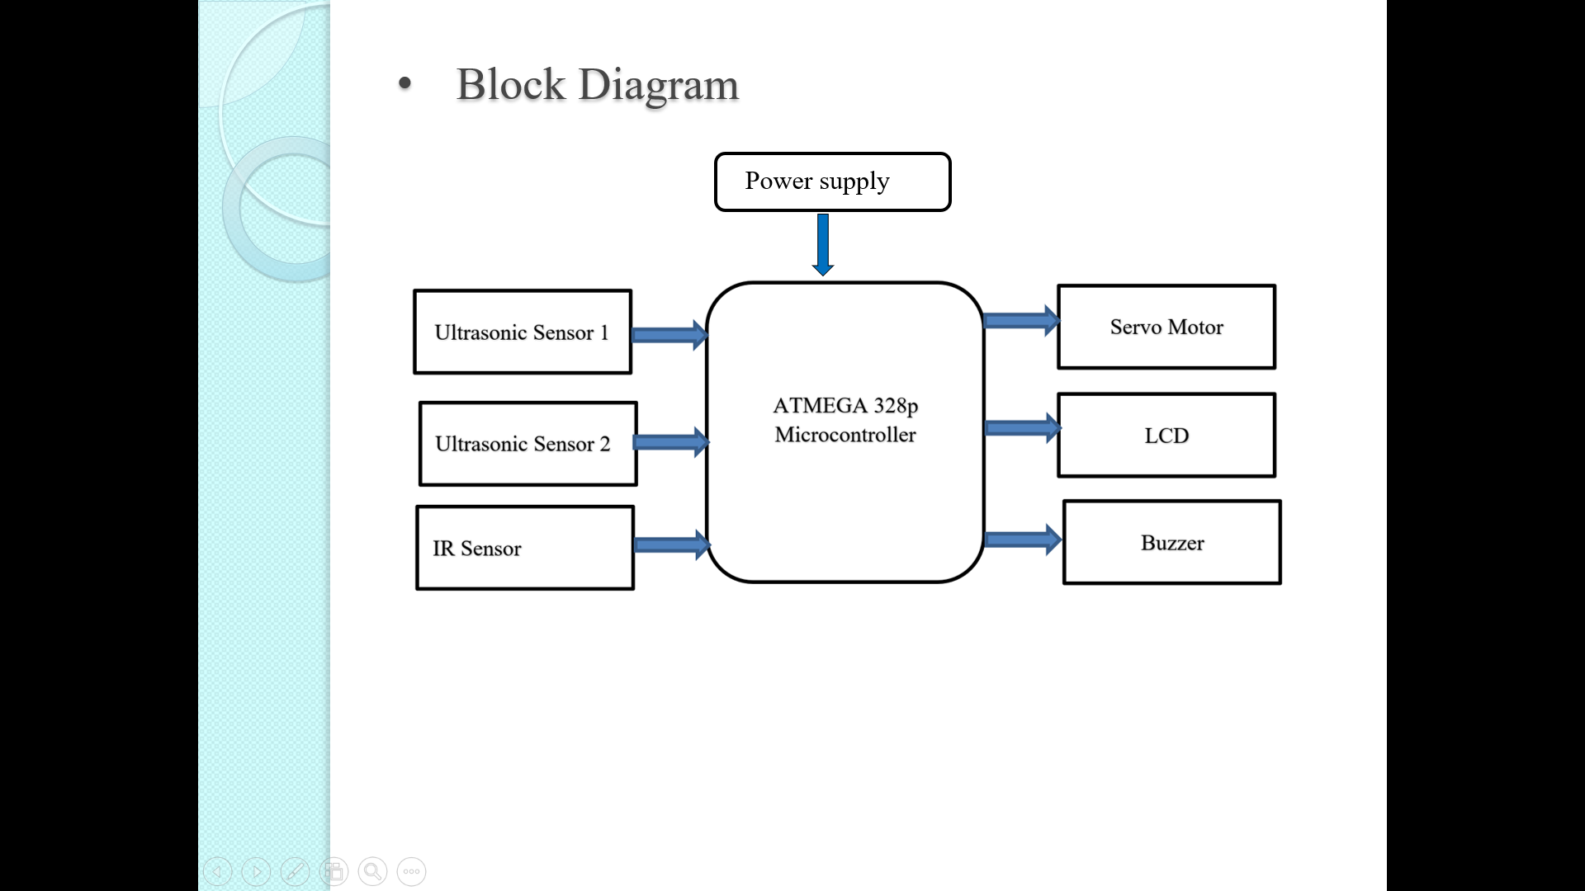

**Project Idea:**

* An efficient method to segregate the waste easily that

has been designed in our project, “Automated Dry and Wet

Waste Segregator and Monitoring System”. As the use of

technology is increasing day by day, by taking the advantage

of this new age technology we are focusing on managing

waste effectively.

* This project will be helpful in our society at

primary level for segregating waste initially it will make the

process easy and less time consuming

**Applications:** _

1. It can be used for collecting the garbage from public places, household, etc.

2. Reducing human time and effort which requires to segregate garbage.

3. Municipal Corporation can use it as replacement to the traditional dustbins.

***Interaction with Mini-Project Coordinator***

|  |  |  |  |  |
| --- | --- | --- | --- | --- |
| **Sr.No** | **Date** | **Interaction with Mini-Project Coordinator** | **Sign of Students** | **Sign of Mini-Project**  **Coordinator** |
| **1.** | **12/03/2022** | **Presentation is given to the industrial expert** |  |  |
| **2.** | **21/03/2022** | **Taking suggestion from project coordinators** |  |  |

|  |  |  |  |  |
| --- | --- | --- | --- | --- |
| 3. | 04/04  /2022 | **Submission of poster,synopsis etc** |  |  |

***Interaction with Industry Expert***

Project ID: ­­­­­ A8 Date of PPT Presentation: 12/03/2022

Project Title: Dry/ Wet Garbage Segregation and Monitoring

Modifications Suggested:

Instead of wooden surface use aluminium foil surface for better moisture detection.

**Name and Sign of** Dr.Mrs. K. A. Adoni, Mr. Ramgopal Sahu

**Industry Expert Mini-Project Coordinators**

***Feasibility Report***

**I. Technical and Commercial Aspect**

1. Availability of components:

|  |  |  |  |  |  |  |  |
| --- | --- | --- | --- | --- | --- | --- | --- |
| Sr. No. | Name of Component | Specification | Quantity | Rate(Rs.) | Market Availability  (Local/ Online) | Time to purchase  (days) | Total Cost (Rs.) |
| 1. | Atmega 328P Microcontroller | Core size 8 bit | 1 | 1000 | Local | 1 | 1000 |
| 2. | IR sensor | Distance measuring range : 2-30cm | 1 | 265 | Local | 1 | 265 |
| 3 | Ultrasonic sensor | Sensing range:40-300cm | 2 | 250 | Local | 1 | 500 |
| 4 | Servo Motor | Rotation 0-180 degree | 1 | 248 | Local | 1 | 248 |
| 5 | LCD Display | Dimension: 16X2 cm | 1 | 301 | Local | 1 | 301 |
| 6 | Buzzer | Operating voltage range 3-24 DC | 1 | 100 | Local | 1 | 100 |
|  |  |  | Grand Total | | |  | 2414 |

**\*Note: If components are purchase online, mention shipping charges separately.**

1. Software tools required for PCB making, simulation, programming etc.?

|  |  |  |
| --- | --- | --- |
| Sr. No. | Software details  (version, open source / license / trial / student) | System requirement for installation |
| 1. | Zenit PCB |  |
| 2. | SPI |  |
|  |  |  |
|  |  |  |
|  |  |  |

1. Enclosure details (Dimensions, Weight, Material used):

Material : metal, aluminium foil, cardboard sheet etc

Weight : 3kg

**II. Behavioral Aspect**

1. Is the project hazardous to environment:

NO .

1. Have you considered societal, health, safety, legal and cultural issues while selecting project?

Yes , we consider everything.

1. Mention the applicability of the project:

1.Garbage segregation project use in public places, societies, gardens etc.

2. Resendtial societies uses it for mainting cleanliness.

**III. Distribution of Work**

1. Name of student: Omkar Ankush Bhilare.

a. Knowledge of component verification and testing: Yes

b. Knowledge of software used: Yes

c. PCB making and soldering: NO

d. Programming Languages Known : Yes

e. Troubleshooting and testing skills. :Yes

f. Planned Man hours : NO

1. Name of student: Rishikesh Ghanshyam Datey.

a. Knowledge of component verification and testing: Yes

b. Knowledge of software used : Yes

c. PCB making and soldering : Yes

d. Programming Languages Known : Yes

e. Troubleshooting and testing skills. : Yes

f. Planned Man hours : Yes

1. Name of student: Neha Sandeepan Ghogre

a. Knowledge of component verification and testing: No

b. Knowledge of software used: No

c. PCB making and soldering : Yes

d. Programming Languages Known : No

e. Troubleshooting and testing skills. : Yes

f. Planned Man hours : Yes

**Plan of Action**

|  |  |  |  |  |  |
| --- | --- | --- | --- | --- | --- |
| **Sr.No.** | **Date** | **Work planned** | **Signature of Students** | | |
| 1. | 5/03/22 | Formation of groups , synopsis submission |  |  |  |
| 2. | 7/03/22 | Project finalization |  |  |  |
| 3. | 16/3/22 | Distrubution of work , fesibility report submission |  |  |  |
| 4 | 18/3/22 | Simulation |  |  |  |
| 5 | 20/03/22 | PCB design |  |  |  |
| 6 | 21/03/22 | PCB building |  |  |  |
| 7 | 22/03/22 | Soldering and testing |  |  |  |
| 8 | 27/3/22 | Programming and functionality |  |  |  |
| 9 | 29/3/22 | Finishing, enclosing of project |  |  |  |
| 10 | 31/3/22 | Testing troubleshooting |  |  |  |
| 11 | 2/4/22 | Documentation |  |  |  |
|  |  |  |  |  |  |
|  |  |  |  |  |  |
|  |  |  |  |  |  |

**Name and Signature of Project Guide Signature of Mini-Project Coordinators**

Dr. Mrs. K. A. Adoni

***Sponsorship Letter***

***(Paste Sponsorship Letter here)***

***Fortnightly Planning Sheet***

|  |  |  |  |  |  |
| --- | --- | --- | --- | --- | --- |
| **Sr. No.** | **Date** | **Activity planned** | **Activity Executed** | **Sign of Students** | **Sign of Guide** |
| 1. | 7/03/2022 | Formation of group and submission of synopsis | Yes |  |  |
| 2 | 15/03/2022 | Finalization of mini project and distribution of work | Yes |  |  |
| 3 | 25/03/2022 | Circuit schematic and simulation | Yes |  |  |
| 4 | 10/04/2022 | PCB design | Yes |  |  |
| 5 | 14/04/2022 | Hardware and programming | Yes |  |  |
| 6 | 21/04/2022 | Testing and debbuging | Yes |  |  |
| 7 | 26/04/2022 | Enclosure design and Testing Final Project | Yes |  |  |
| 8 | 05/05/2022 | Documentation: preparation , checking and correcting draft copy of report , ppt etc. | Yes |  |  |

***Block Diagram***



***Flowchart / Algorithm***

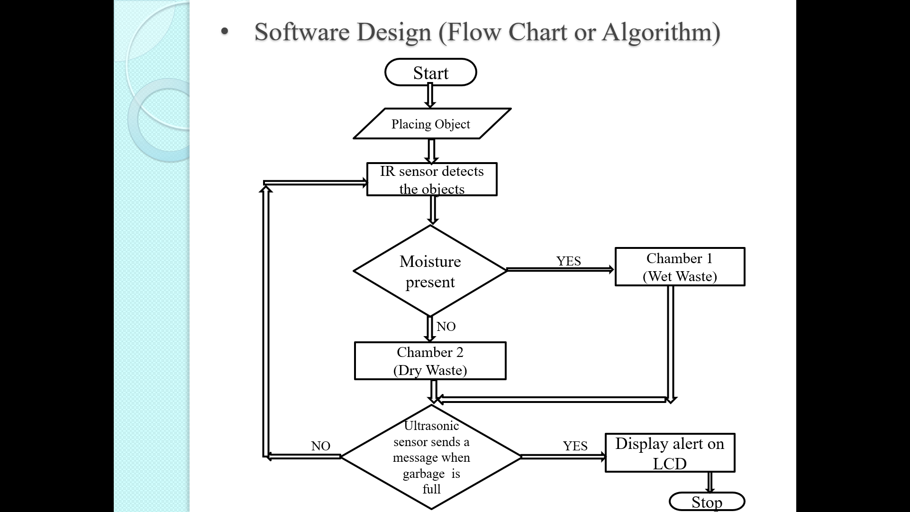

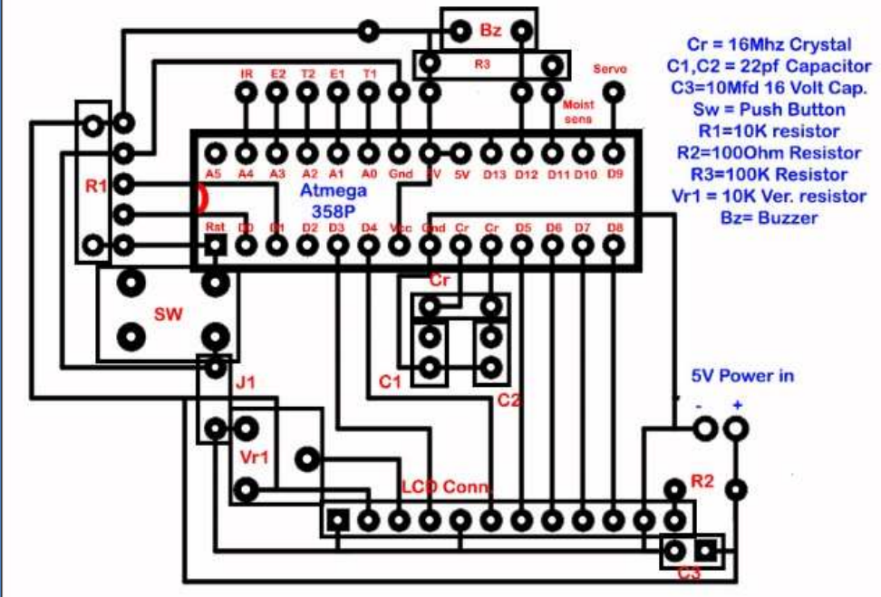

***Rubrics for Evaluation of Project Exhibition***

|  |  |  |  |  |  |
| --- | --- | --- | --- | --- | --- |
| **Parameter** | **Criteria** | **RATING** | | | |
| **Average** | **Satisfactory** | **Good** | **Excellent** |
| **1 or 2** | **3** | **4** | **5** |
| Project Idea / Theme (CO1) | Creativity | Common idea and basic implementation | Simple idea and simple implementation | Simple idea but implemented innovatively | New project idea and implemented innovatively |
| Literature and Market Survey (CO1) | Coherence | Very limited Literature and Market survey | Literature and Market survey carried out , but able to explain some of them | Literature and Market survey carried out, but able to explain most of them | Appropriate Literature and Market survey, able to relate it with project parameters |
| Hardware / software implementation of Project (CO2) | Implementation | Hardware design and software design are partially ready. | Hardware design and software design are ready but results are not proper | Hardware design and software design are ready. Enclosure is yet to prepare. Project is ready with some good features and students are somewhat aware of technical know-how. | The project is ready in all aspects with some innovative features and students are thorough about technical know-how. |
| Speaking Skills, Presentation,  (CO3) | Organization, Presentation  Skills | Students are lacking in communication skills  Need to improve Presentation skills for effective delivery | Project is ready but students lack in communicating technical know-how of it  Few Team members were participated  The presentation   required slight changes to increase effectiveness of the contents and pace | The transitions and / or flow were somewhat difficult to follow.  Team members were mostly audible and / or fluent on the topic | The transitions and flow was easy to follow.  Slides were error - free and logically presented.  Team members were poised and had clear articulation. |
| Extension  (CO4) | Future Scope | With Minor Changes same implementation can be used for another application | Some changes gives Project Expansion to BE project | The Project Can be converted to Product Level | The Project Can be Patentable |

***Project Exhibition: Performance Evaluation***

Project ID: A8

Project Title: Dry/ Wet Garbage Segregation and Monitoring

Remarks: _____________________________________________________________

_____________________________________________________________________

_____________________________________________________________________

_____________________________________________________________________

_____________________________________________________________________

Name and Sign of Name and Sign of Name and Sign of

Internal Examiner Industry Expert Project Guide

Dr. Mrs. R. S. Kamathe Dr. Mrs. K. A. Adoni, Mr. Ramgopal Sahu

H.O.D. Mini Project Coordinators

***Sponsoring Company Data***

Project Title: Dry/ Wet Garbage Segregation and Monitoring

Project ID: A8

Internal Project Guide: Mr. Ramgopal Sahu

External Project Guide: _____________________________

Name of Students: 1. Omkar Ankush Bhilare

2. Rishikesh Ghanshyam Datey

3. Neha Sandeepan Ghogare

|  |  |
| --- | --- |
| Name of The Sponsoring Company |  |
| Address |  |
| Office Contact Number |  |
| HR Contact Details (Name, Email-ID, Phone) |  |
| Website |  |
| Work Domain of Company(Product Technology Used) |  |
| Wide Area of Company  (e. g Signal Processing, Communication) |  |

***Sponsoring Company Visit Report***

Project Title: Dry/ Wet Garbage Segregation and Monitoring

Project ID: A8________________________ _________________ _________

Internal Project Guide: Mr . Ramgopal Sahu _________________________________

External Project Guide: ________________________________________________________

Date of Visit: _________________________________________________________________

Time of Visit:_________________________________________________________________

Name of the Sponsoring Company: _______________________________________________

Progress Discussed: ____________________________________________________________

_____________________________________________________________________________

___________________________________________________________________________

Project Status (Percent Project Completion & Expected Date of Completion):

**Sign of Internal Project Guide Sign of External Project Guide**

***Project Progress Report***

**Title of Project:- Dry/ Wet Garbage Segregation and Monitoring**

**Work Done:- ___________________________________________________________________________________________________________________________________________________________________________________________________________________________________________________________________________________________________________________________________________________________________________________________________________________________________________________________________________________________________________________________________________________________**

**Achievements:-**

**_______________________________________________________________________________________________________________________________________________________________________________________________________________________________________**

|  |  |  |
| --- | --- | --- |
| **Signature of Students** | **Signature of Guide** | **Signature of H. O. D.** |
|  |  |  |
|  |  |  |
|  |  |  |

**Final working project hardware:**

